Completed coding the VR Ring to automatically generate 300 lights in a sphere around the participant. I could not figure out the proper angles to use for a dodecahedron so I made a sphere with rows every 10 degrees with more lights closer to the center rows.

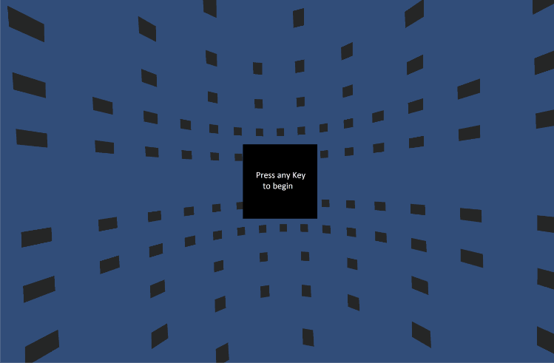

Above: Participant’s view (Note: Field of View is much narrower when viewed through Oculus)

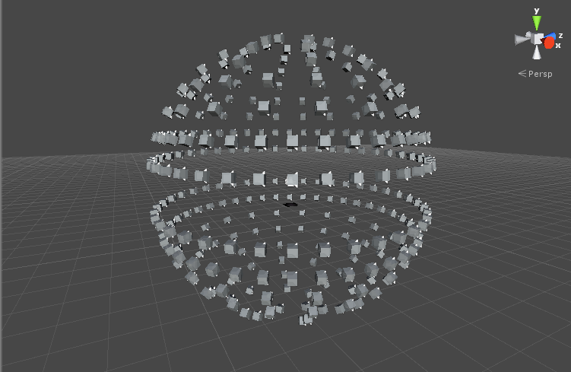

Above: Outside view of the sphere

Notes: During testing I’ve found that the 3D sound was questionably useful, as it only told me if the sound was to my left or right, not height or if it was behind me.